Algebra 1: Unit 6, Lesson 8

- Translate the phrase for the inequality.
$$a≥b$$
$a$ is at least $b$

- Sal is ordering takeout for a party night with $20$ guests. A family-sized chicken bucket will feed at least $8$ guests and an extra-large chicken bucket will feed $5$ guests. This situation can be represented by the inequality $8x+5y≥20$, where $x$ is the number of family-sized chicken buckets and $y$ is the number of extra-large chicken buckets.
The point $(4,-1)$ is not a viable solution because Sal ________________________ chicken buckets.
Cannot buy negative amounts of

- Josie is shopping for items for a celebration. Value-pack packages of plates contain enough for $100$ guests and regular-sized packages contain enough for $25$ guests. There must be at least enough plates for $200$ guests who plan to attend. This situation can be represented by the inequality $100x+25y≥200$, where $x$ is the number of value-pack packages and $y$ is the number of regular packages.
The combination of value-pack packages and regular packages that will ensure that Josie has at least one plate for each guest is modeled in the graph shown.
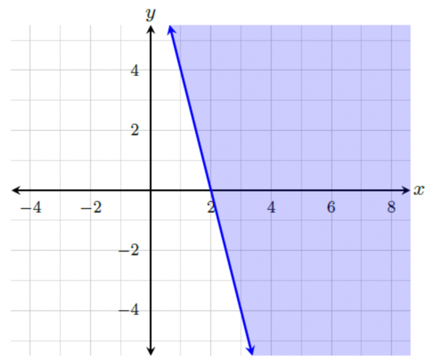
Will $1$ value-pack and $1$ regular pack ensure that Josie has at least one plate for each guest?
No, it will not.

